EmpowerDatabase - Create Executable

The EmpowerDatabase project is part of the EmpowerRelease solution.
EmpowerDatabase.exe is created when you Build or Rebuild the EmpowerRelease solution.
Because our Empower Database tool on the SQL Server Management Studio menus points to EmpowerDatabase.exe in the Release folder, we need to do a Release build when we create a new EmpowerDatabase executable.

When Empower Database is added as an External Tool in SQL Server Management Studio (SSMS) the folder is specified by clicking the ellipsis next to the Command prompt. When the Open File response window opens, select the EmpowerDatabase.exe.

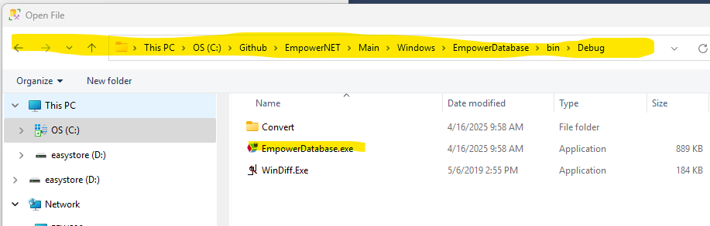
It does not matter whether you are using the Debug or Release sub-folder of the Bin Folder. Just make sure you are pointing to the sub-folder you just built/rebuilt in SSMS, External Tools, Empower Database, Command.

When Bob’s new KPMF table-valued functions weren’t being picked up by the code that creates scripts, I had to
- Change two queries in Function GetDefinitions in EmpowerMaintenance > Processes > Database.vb to include xtype TF (table function).

This is one of the queries.
SELECT
sysobjects.name, sysobjects.xtype,
ISNULL(sys.sql_modules.definition, sys.system_sql_modules.definition) AS definition
FROM
sysobjects INNER JOIN
sys.schemas ON
sysobjects.uid = sys.schemas.schema_id LEFT OUTER JOIN
sys.sql_modules ON
sys.sql_modules.object_id = sysobjects.id LEFT OUTER JOIN
sys.system_sql_modules ON
sys.system_sql_modules.object_id = sysobjects.id
WHERE
sysobjects.xtype IN ('P', 'V', 'IF', 'TF') AND
sysobjects.category = 0 AND
sysobjects.name NOT LIKE '%diagram%' AND
sysobjects.name NOT LIKE '%aspnet%' AND
sys.schemas.name = 'dbo'
ORDER BY
sysobjects.xtype, sysobjects.name
- Add TF to the property Type Get case statement in EmpowerMaintenance > Models > Definition.vb.
